Aurora: Positioning Brief
Kenyan Commercial & Industrial (C&I) energy intelligence · October 2026

Positioning statement
Aurora is an AI energy-intelligence platform for Kenyan commercial and industrial sites. It turns the meters and inverters a plant already has into lower demand charges, fewer power-factor penalties, and smarter use of grid, solar and genset power.

The problem
Kenya Power's C&I tariffs charge for more than consumption. Bills combine energy rates (standard, time-of-use and bulk), a demand charge per kVA set by the monthly peak, and other pass-through charges, with differences by supply voltage. Most plants see only the monthly total, so they cannot tell which peak, which load, or which power-factor problem drove the cost. Many also run grid, solar and diesel together with no single view of what each source really costs.

Target customer
- Who: mid-sized manufacturers and agro-processors on lower-voltage C&I supply, ideally with a genset or solar array.
- Buyer: plant or facilities manager. Champion: finance or operations lead.
- Avoid at first: heavy industry on the highest-voltage tiers, where sales cycles are long.

Value propositions
- Demand and peak management: forecasts the monthly maximum kVA, warns before a peak, and recommends load shifting.
- Tariff-aware scheduling: moves flexible loads such as compressors, chillers and batch processes into cheaper off-peak windows.
- Power factor and quality: flags penalties and quantifies the saving from correction.
- Hybrid source optimization: compares cost per kWh across grid, solar and diesel, and logs outages and voltage events.
- Billing verification: reconciles the plant's own readings against the utility bill.

Why Aurora
- Software-first: works from existing meters, inverters and gensets, with no new hardware or certification to start.
- Local tariff intelligence built around Kenya Power and EPRA rules rather than generic global tools.
- Fast to deploy and priced to prove itself: a share of verified savings removes the buyer's risk.

Go-to-market
Phase | What | Goal
1 | Monitoring and optimization software reading existing equipment over Modbus RS-485 or TCP | Prove savings on a real bill
2 | Aurora three-phase metering hardware (CT inputs, RS-485, LTE) | Accurate data where no open interface exists
3 | Expand across grid-connected and hybrid sites | Whole-ecosystem energy intelligence
Pilot: one plant, a 60 to 90 day baseline, then a before-and-after comparison on the bill.

System architecture
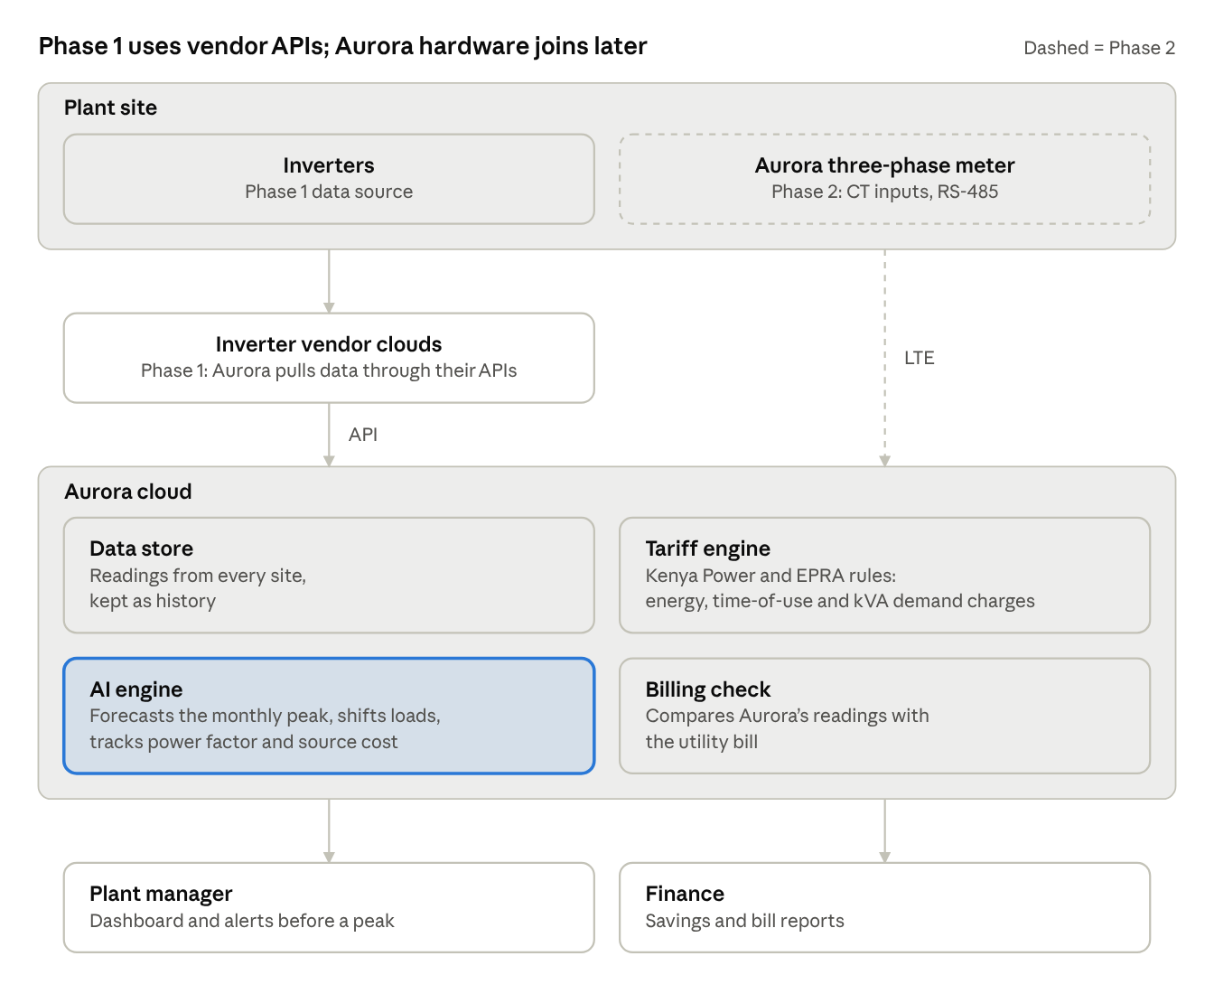
system architecture · 4 layers, 2 data paths
Phase 1 pulls inverter data from the vendors’ cloud APIs; the dashed Phase 2 meter sends its own data over LTE. Both paths land in one cloud, where the tariff engine and AI engine turn readings into peak alerts and savings reports.

Proof points to build
- A measured percentage reduction in demand charges at the pilot site.
- Power-factor correction savings quantified from real data.
- A one-page case study the next customer can read in two minutes.

Risks and open questions
- Established vendors already sell energy management systems, so the edge must be local tariff expertise, price and speed.
- Data access is the main bottleneck: some plants have meters with no open interface.
- Tariff figures must be confirmed against the current EPRA schedule before any savings claim goes into a deck.
- Three-phase hardware needs a new design, because the current PZEM-based board is single-phase.

